Open-DAQ: OPEN-SOURCE FPGA Platform for Data Acquisition
Engineering Design Document

Summary
This work provides an affordable, open-source FPGA based data acquisition system for validating novel ADC prototypes operating at 100s of MHz differential data output. The architecture uses differential to single ended buffers followed by a custom SERDES, FIFO, and DMA which passes the data into DRAM. Then, Linux reads the data and writes the data to a file. The design demonstrates high data throughput with a range of clock inputs and high levels of customization from the incorporation of Linux into the system. Experimental data capture validates robustness and design integrity.

Background and Design Overview
Current testing protocols for novel A/D converters include the invariable use of a logic analyzer to collect the high-speed differential output data, however most oscilloscopes use FPGAs internally to collect the data presented to the user. This raises a key question: Can an FPGA be used to collect data and characterize a novel A/D converter instead of a logic analyzer? In this document a system to do just that is detailed. The approach in this document will be broken into 2 different areas, the PL design and the PS design. Here PL stands for programmable logic, which refers to the FPGA side of the design. PS stands for processing system, which refers to the hard cores that are built into the Zynq SoC.
Fig. 1: Complete Design Overview and Breakdown

In this experimental design, the board in question is the Zedboard from Digilent. For more information regarding this board, please refer to the manual available at link 1.

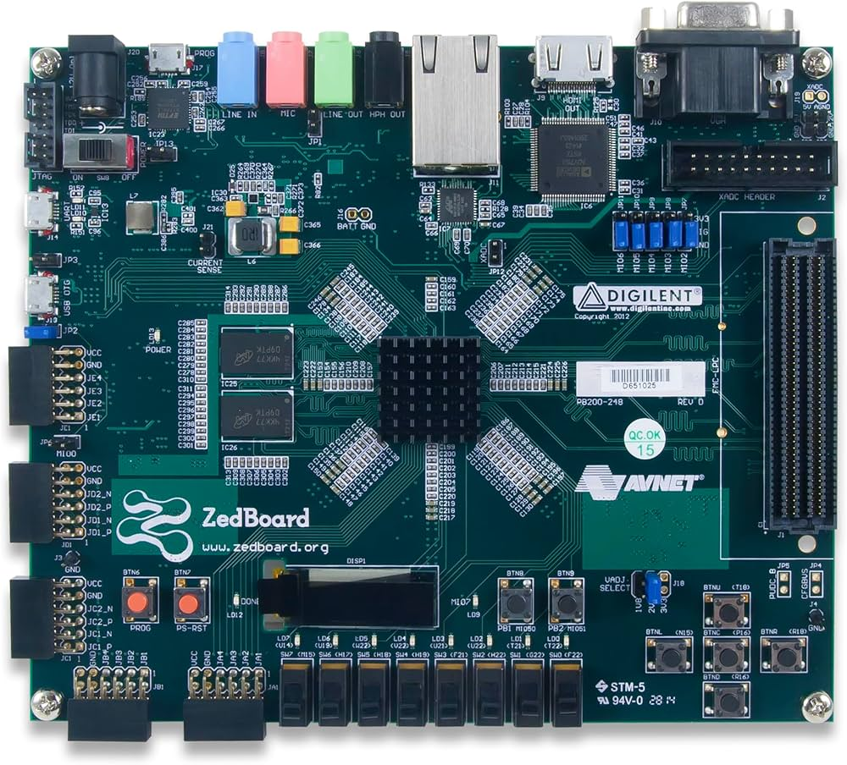
Fig. 2: Zedboard

PL Design Decisions / Methodology
The figure below shows the experimental breakdown of the PL side of the proposed design. Note: FIFO means “first in, first out” and is implemented here as a buffer. DMA stands for direct memory access. Serdes stands for serialize and deserialize. PRBS-15 is pseudo-random bit sequence.
a)
b)
Figure 3: a) PL Design for 3 channel design. b) PL Design for single channel design.
Figure 4: Serdes Internal Breakdown

Block | IP/ Custom | Vivado BD / IP name | Interconnect Bus
PRBS-15 Generator | Custom | PRBS_15_0 | None
Differential to Single Ended Buffers | Xilinx IP | lvds_to_lvcmos_with_clk | None
AXI-Adapter | Custom | AXI_Adapter_0 | AXI-4S
AXI-Frame-Corrector | Custom | axi_frame_corrector_0 | AXI-4S
FIFO | Xilinx IP | AXI4-Stream Data FIFO | AXI-4S
DMA | Xilinx IP | AXI Direct Memory Access | AXI-4S, AXI S2MM, AXI 4
Table 1: PL IP Breakdown
The engineering design decisions here will be further broken down into each IP block first and then explained from a holistic perspective.
PRBS-15 Generator: The generator in this design serves to provide BIST (built in self-test) functionality to allow the design to be quickly prototyped, modified, and verified experimentally without the use of any external equipment. Furthermore, the inclusion of such a BIST allows the design and development of any DAQ (data acquisition) system on the board to be fully portable, and can be done from anywhere, even where testing equipment is not available. The generator is simply implemented in Verilog and emulates the connection of a novel A/D converter. It does so by taking in the 100 MHz PL system clock, and outputs a serial string of PRBS-15 bits. An important note to make here is that this generator does not stop, it always sends bits, and one needs to be able to buffer those bits without dropping one, emulating a novel A/D converter perfectly. Using this sequence, one can test the entire data path and test for continuity of bits on the receiving end by running a PRBS descramble script in MATLAB. If all the bits were received correctly, then one should see a continuous flat line showing that all the bits were able to be resolved. Any break in the bits suggests an issue in the data path.
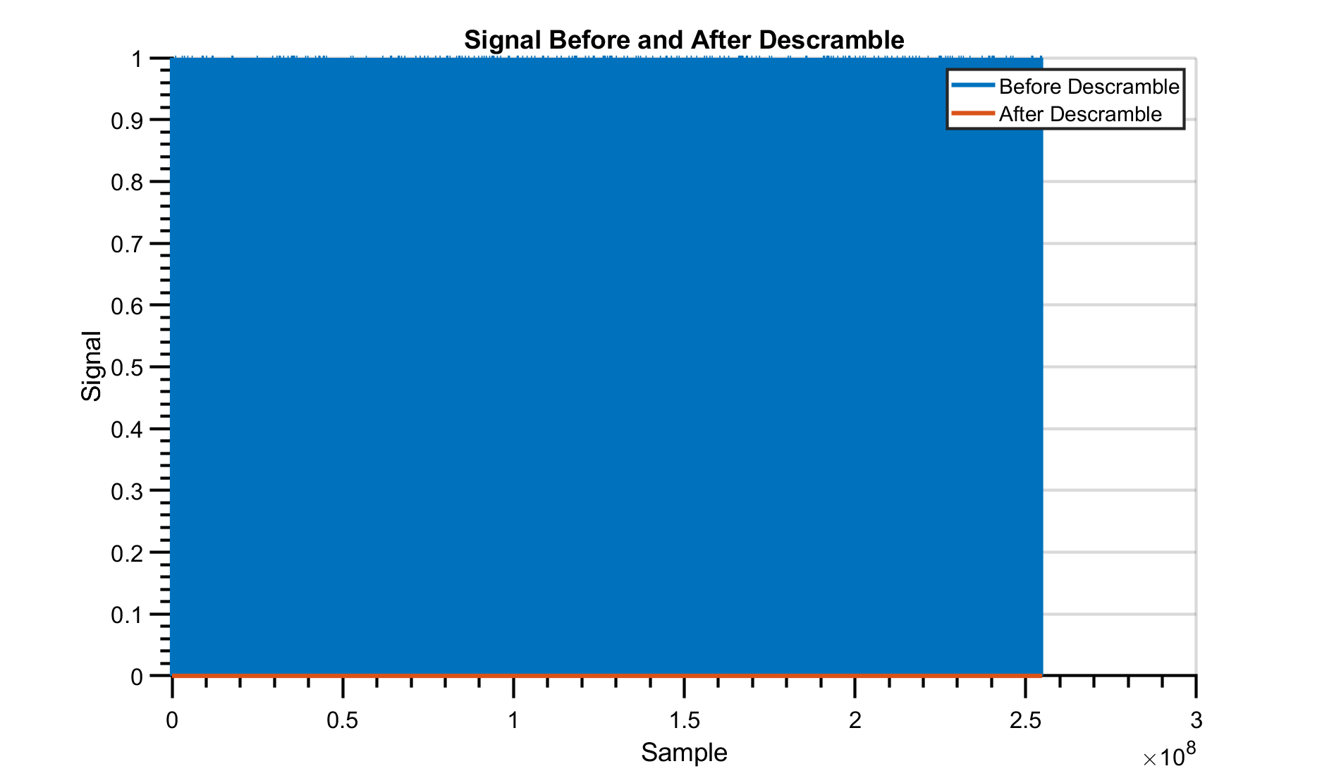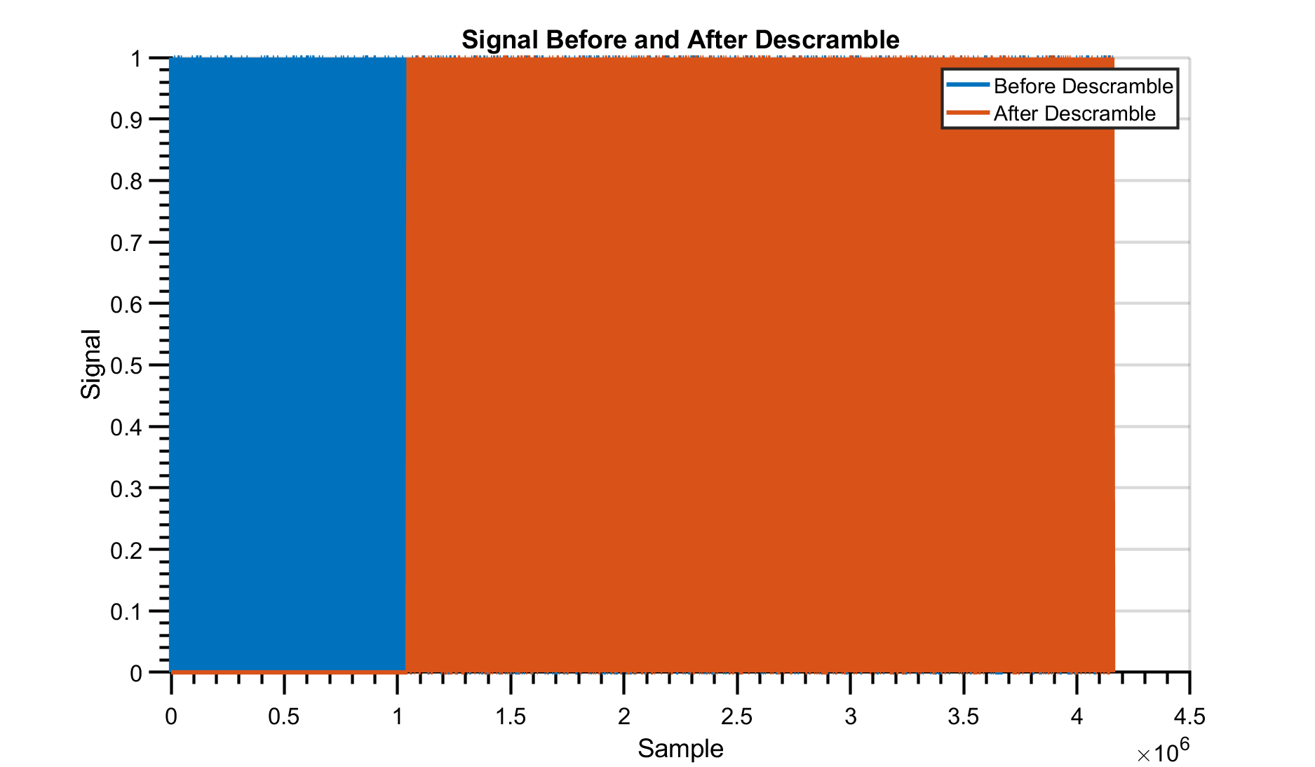
(a) (b)
Fig. 4:
(a) Successful PRBS BIST result showing that 255 Megabit was able to be continuously captured.
(b) Unsuccessful PRBS BIST result showing that the first Megabit was continuous, but after that there is a break.

Mux: The select line of the mux is connected to a switch on the Zedboard and effortlessly allows one to switch between accepting external data and BIST functionality in real time. Moreover, one can use this switch to quickly debug if there is an FPGA related data capture issue or a A/D converter data capture issue by simply flipping the switch, capturing the BIST data, and analyzing the results. If one receives what is seen in Fig 4a, then the FPGA is working faultlessly.

Update for Mux 2/20/2026: For the 3 channel and single channel design, the mux is no longer implemented. This is due to Vivado’s autorouter simply placing this mux on a standard LUT on the clk tree circuit, which causes massive setup and hold time failures. Therefore, in the single channel design, the PRBS generator is still implemented, but it is directly connected to FPGA output pins JD1P-N and JD2P-N. This way, it still can be used by directly wiring the prbs output pins to the data inputs, creating a “loopback” test.
For the 3-channel design, for simplicity’s sake, the PRBS gen was deleted, but can be added back at any time, using the same pinout that is found in the single channel design.
Differential to Single Ended Buffers: These simply serve to convert the high-speed differential input data and clock from the novel A/D converter to single ended for the rest of the PL to work with.
Update as of 2/20/2026: These buffers have been overhauled to support the higher (250 MHz) clock speeds. The changes are as follows.
- Inclusion of a BUFR (Regional Clock Buffer) which implements a regional clock tree circuit for high speed clks to meet setup /hold requirements as well as skew.
- Resynced data: Once the input clock has become single ended, its passed through the BUFR, and then using an always@(LVDS_CLK_BUFR) block, the incoming single ended data is resynced to the clock, preventing shifting of data relative to the BUFR clock.
- For the 3 channel data and clock sync, the and gate on the clk circuit was removed, and was instead implemented by connecting the MMIO Reg (AXI GPIO) to the clk enable input on the BUFR. Data remains synced by the and gate.
Protocols:
- AXI-4S: This is the first and most important protocol used in this design. AXI-4S, or Advanced eXtensible Interface -4 Stream is ARM’s protocol that they use to connect various IP blocks in their SoC and MCU designs. This flavor (Stream) is designed specifically for blocks that are streaming data. With a high throughput data stream like the one implemented in this design, a simple reliable bus interconnect is vital. The protocol is further broken up into the 5 signals that are used in this design. Those signals are tdata[31:0], tkeep[3:0], tlast, tready, and tvalid. Tdata is the data vector and holds all the data one wants to transmit. Tkeep holds how many of those bytes are valid. In the case of this design, this signal is necessary but can effectively be ignored once set to 4’b1111. All 4 bytes are valid in this design, and the selectively valid bytes feature of AXI-4S is not implemented in this design. Tlast signals the EOF or end of frame to the downstream DMA and can be thought of as the end of packet signal that only goes high at the end of the transaction. For the validated design, tlast is asserted once every 32MB and only once. Any more than that, and one gets massive discontinuities in the PRBS output file. Tready is the input to the block from whatever is downstream, and signals that whatever is downstream is ready to accept data. Tvalid is the last signal, and it simply states that the data being presented to the downstream block on tdata is all valid and can be accepted. There are a lot of regulations around the timing of tready and tvalid, and will not be discussed here, but more can be found at link 2.
- AXI-4: This is the “big brother” of AXI-4S and is part of the larger ARM family of interconnects. This interconnect can handle 500+ MBps and is quite robust, however for the purposes of this design, it will not be explained further, as it is an extremely complicated bus protocol comprised of 25+ signals and is not needed, as the IP blocks implement it.
- AXI-S2MM: This is a continuation of AXI – 4S but is designed with MMIO (Memory Mapped IO) in mind. This is the bus protocol that allows one to send data from the PL to PS (Linux). S2MM stands for Stream to Memory Mapped. As one can imagine, as one only wants to receive data into DRAM, MM2S is unused, but can be used in the future in terms of expansion.
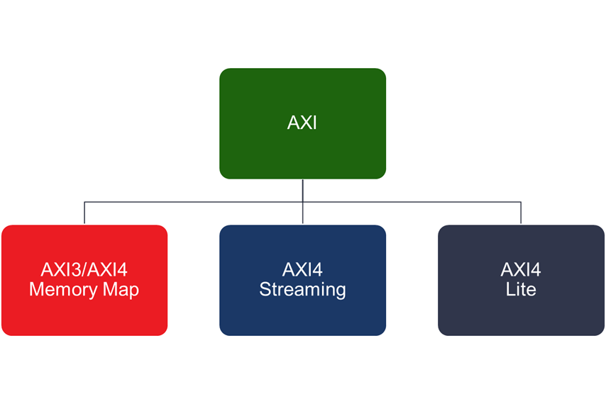
Figure 5: Bus Protocol Relation.
Serdes:
- AXI- Adapter: This is the first of 2 “internal” Serdes blocks that take the serial data from the buffers and deseralize the data onto the AXI-4S protocol. Given the simpler nature of AXI-4S vs AXI-4 this and the following block are custom, and allow one to take in the continuous, nonstop input data that is without a protocol attached to it, and deserialize it into 32-bit packets that utilize the AXI-4S interface. Using a Serdes is mandatory in this case, as without it, one cannot interface with the Xilinx FIFO and DMA, and writing a custom memory mapped DMA and FIFO to Linux is far harder than simply converting the data to utilize the bus protocol. This block operates by taking in the data and clock and continuously shifting the data into a shift register while handling the bus protocol side simultaneously. This approach works partially in practice, and the complexity of having to be able to hold certain words for >32 cycles (1 packet) messes with the internal timing of the FSM (Finite State Machine) since it must handle both input and output. This is why the second block, AXI-Frame-Corrector, was implemented.
- AXI-Frame-Corrector: This block serves to buffer and correct any protocol violations created by the AXI Adapter to ensure full compliance with the protocol standards and have a small ~64-word buffer internally to handle any stream stalls, which the AXI Adapter cannot handle on its own to ensure no data is lost. This is achieved by effectively “post processing” the handshake signals from the AXI Adapter before they are presented to the FIFO. In this corrector, a worst-case scenario is assumed, and the outputs are corrected to err on the side of caution as much as possible. As an example, tvalid is pulled low immediately after tready is high, and a transfer is detected to ensure that the downstream IP block does not take any data in between, even if the data remains constant and valid to ensure as much robustness as possible to error. In this block, a “beats” output signal is also seen, and its purpose is to alert the user, via an ILA (integrated logic analyzer) when tlast goes high, and to alert the user as to what state the corrector is in.

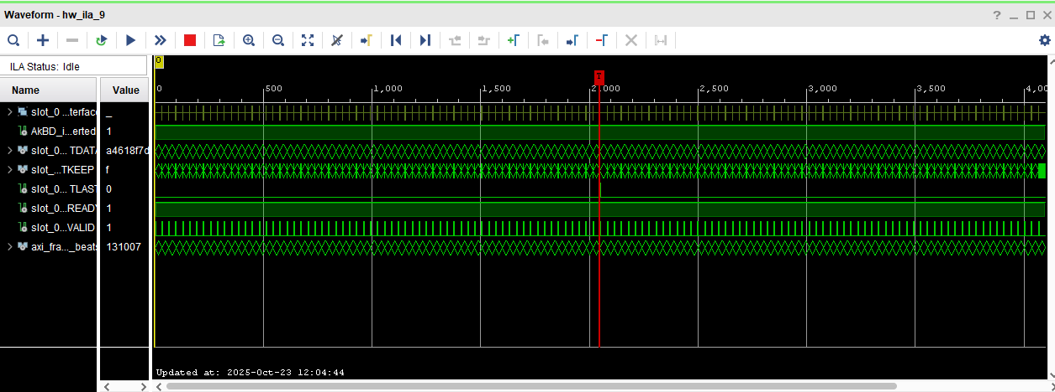
Fig. 6: Real time transaction output of AXI-Frame-Corrector

FIFO: In this design, the FIFO serves a major role, both as a buffer, but also as a CDC (Clock Domain Crossing) moderator. A design constraint that was imposed was that this design needs to be able to accept data from an experimental A/D converter at a range of input clock frequencies. To satisfy this requirement, a CDC FIFO was utilized, specifically Xilinx AXI 4 Stream Data FIFO. The size of this FIFO was set at 32768 words, or ~1.2 Megabit was chosen. This happens to be the largest size of the FIFO that Xilinx supports. Only BRAM and not distributed ram was chosen for this FIFO to ensure that the speed requirements could be met. BRAM uses the SRAM available on die as FIFO storage, while distributed ram uses the flip flops of each LUT in the FPGA to implement storage of sorts. As one can imagine with that type of separated storage, the speed that is supported is much slower, and reliability is far less, which makes BRAM far more suitable for the purposes of this design. Furthermore, 8 CDC synchronization stages were used in this FIFO to eliminate the risk of any CDC related issues. Finally, packet mode, where the FIFO turns off when it sees tlast was turned off, as it caused issues when turned on, and ECC was enabled as to ensure no data corruption at the high speeds that this design achieves. Important note here is that the FIFO and DMA both have a buggy reset, and cannot be reset via Linux without causing issues, therefore just reflashing the board, which it does on bootup is enough to make everything work reliably. This just means that the first 1.2 megabit of data is garbage, but the c code already removes that.

Update as of 2/20/2026: The FIFO size for both designs is no longer the max, ~1.2 megabit, but smaller, which is perfectly fine, and does not affect the ability of the FIFO to both buffer and implement a CDC. The c code still removes 1.2 megabit as a precaution. It is not recommended to change this 1.2-megabit removal from the c code for reliability reasons.

Quick AXI4-S Handshake Explanation.

There are 5 Signals
1) Tready
    - Sent to the block by the receiving peripheral
    - Tells the block when its “ready” to receive data
    - Tdata is only taken in when Tready && Tvalid are both high
    - 1 bit width
    - We say “worst case” when this line has no pattern to being toggled ie when it has completely random behavior.
    - Due to the random behavior on Tready, we cannot predict the behavior of this line, preventing us from exploiting a predictable pattern to make the code simpler.
2) Tdata
    - 4-bit width = 4bytes
    - This line holds the data to be transferred
3) Tvalid
    - This signal originates from the source of the data, it says that the data on the TDATA line is valid and should be taken in.
    - Must be asserted before Tready is
    - Main handshake occurs between Tvalid and Tready.
    - 1 bit width
4) Tkeep
    - Tells the receiving peripheral whether it should transmit the data all the way to the destination or not
    - Bit width = number of bytes
    - E.g. in this case 32 bits = 4 bytes, therefore Tkeep has a 4-bit width.
5) Tlast
    - Allows us to determine “packet” length
    - Not strictly necessary, but is recommended to periodically toggle it high after x amount of transfers to keep everything flowing smoothly.
    - Toggling periodically allows us to prevent the receiving end from saturating and getting stuck.

For more information about the handshake, please visit link [2]

DMA: The AXI DMA or AXI Direct Memory Access is the heart and soul of this design. This design was implemented previously without a DMA, but constantly using the CPU to push data from the FIFO to Linux is possible but only resulted in a net data input of 300Kbit, which was heavily dependent on input clock speed. DMA alleviates this issue by having a high speed and throughput direct connection to the DRAM without having to use the CPU as illustrated by Figure 8. The DMA is not without its complications though, as its use does involve having to write a custom Linux Driver, and userspace code, which will be explained more in detail in the next section. The width of the DMA buffer register is set to 26 bits, which translates to ~64MB as the theoretical max size, and unaligned transfers are allowed to make the transfer as easy as possible. One can enable more channels in the dma as one wants to more read and write channels for future expansion. The DMA, while it may have a max transfer size of 64MB, the largest that has been experimentally verified has been 32MB, when one requests a size larger than 32MB, the DMA times out. Possible room for improvement includes getting multiple packets to work and possibly increasing packet size. The DMA is mapped to a certain memory address which is configurable in Vivado and needs to match as to ensure that the driver can correctly read the memory address which is known as CMA, or contiguous memory allocation as to be able to recover the data correctly. There are 3 memory addresses one needs to keep track of, and they are listed in the following table.

Connection | Interface | Segment | Base Address | Range | High Address
DMA | S_AXI_HP0 | DDR_LOW_OCM | 0x400_0000 | 64MB | 0x7FF_FFFF
DMA | S_AXI_HP0 | HP0_HIGH_OCM | 0xFFFC_0000 | 8K | 0xFFFC_1FFF
DMA | S_AXI_LITE | REG | 0x4000_0000 | 64K | 0x4000_FFFF
a)

Network 0 | Interface | Segment | Base Address | Range | High Address

axi_dma_1
 | S_AXI_HP1 | HP1_DDR_LOWOCM | 0x800_0000 | 64M | 0xBFF_FFFF
 | S_AXI_HP1 | HP1_HIGH_OCM | 0xFFFC_2000 | 8K | 0xFFFC_3FFF

axi_dma_2
 | S_AXI_HP2 | HP2_HIGH_OCM | 0xFFFC_0000 | 8K | 0xFFFC_1FFF
 | S_AXI_HP2 | HP2_DDR_LOWOCM | 0xC00_0000 | 64M | 0xFFF_FFFF

axi_dma_0
 | S_AXI_HP0 | HP0_DDR_LOWOCM | 0x400_0000 | 64M | 0x7FF_FFFF
 | S_AXI_HP0 | HP0_HIGH_OCM | 0xFFFC_0000 | 8K | 0xFFFC_1FFF
Network 1

processing_system7_0
/axi_gpio_0/S_AXI | S_AXI | Reg | 0x4120_0000 | 128 | 0x4120_007F
/axi_dma_2/S_AXI_LITE | S_AXI_LITE | Reg | 0x4041_0000 | 64K | 0x4041_FFFF
/axi_dma_1/S_AXI_LITE | S_AXI_LITE | Reg | 0x4040_0000 | 64K | 0x4040_FFFF
/axi_dma_0/S_AXI_LITE | S_AXI_LITE | Reg | 0x4000_0000 | 64K | 0x4000_FFFF
b)

Table 2: a) MMIO Address Table for single channel design. b) MMIO address table for 3 channel design.

Interface | Use
S_AXI_HP0, DDR_LOW_OCM | Stream to DDR, Low On Chip Memory
S_AXI_HP0, HP0_HIGH_OCM | Stream to On Die SRAM, High On Chip Memory
S_AXI_LITE, REG | DMA Control Registers

Table 3: MMIO Meanings

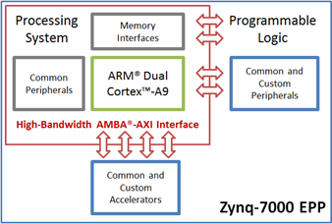
Figure 7: Zynq SoC PS-PL Bus Connections

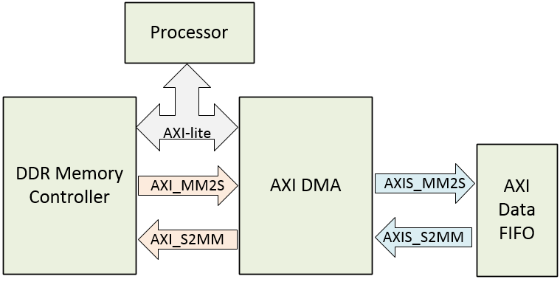
Figure 8: DMA Connections.

Figure 9: Detailed PL Block Diagram

Through this breakdown of each individual component in the PL, one can come to understand the reasons why each block was chosen and how they all interact together for the first step in the data acquisition process, which is to put the data into DRAM. Each component here has an important part to play, and a fault in any of them causes the entire process to be faulty. It is extremely important that the fine details of each block are carefully reviewed and thoroughly understood before making any changes, as any troubleshooting is non-trivial.

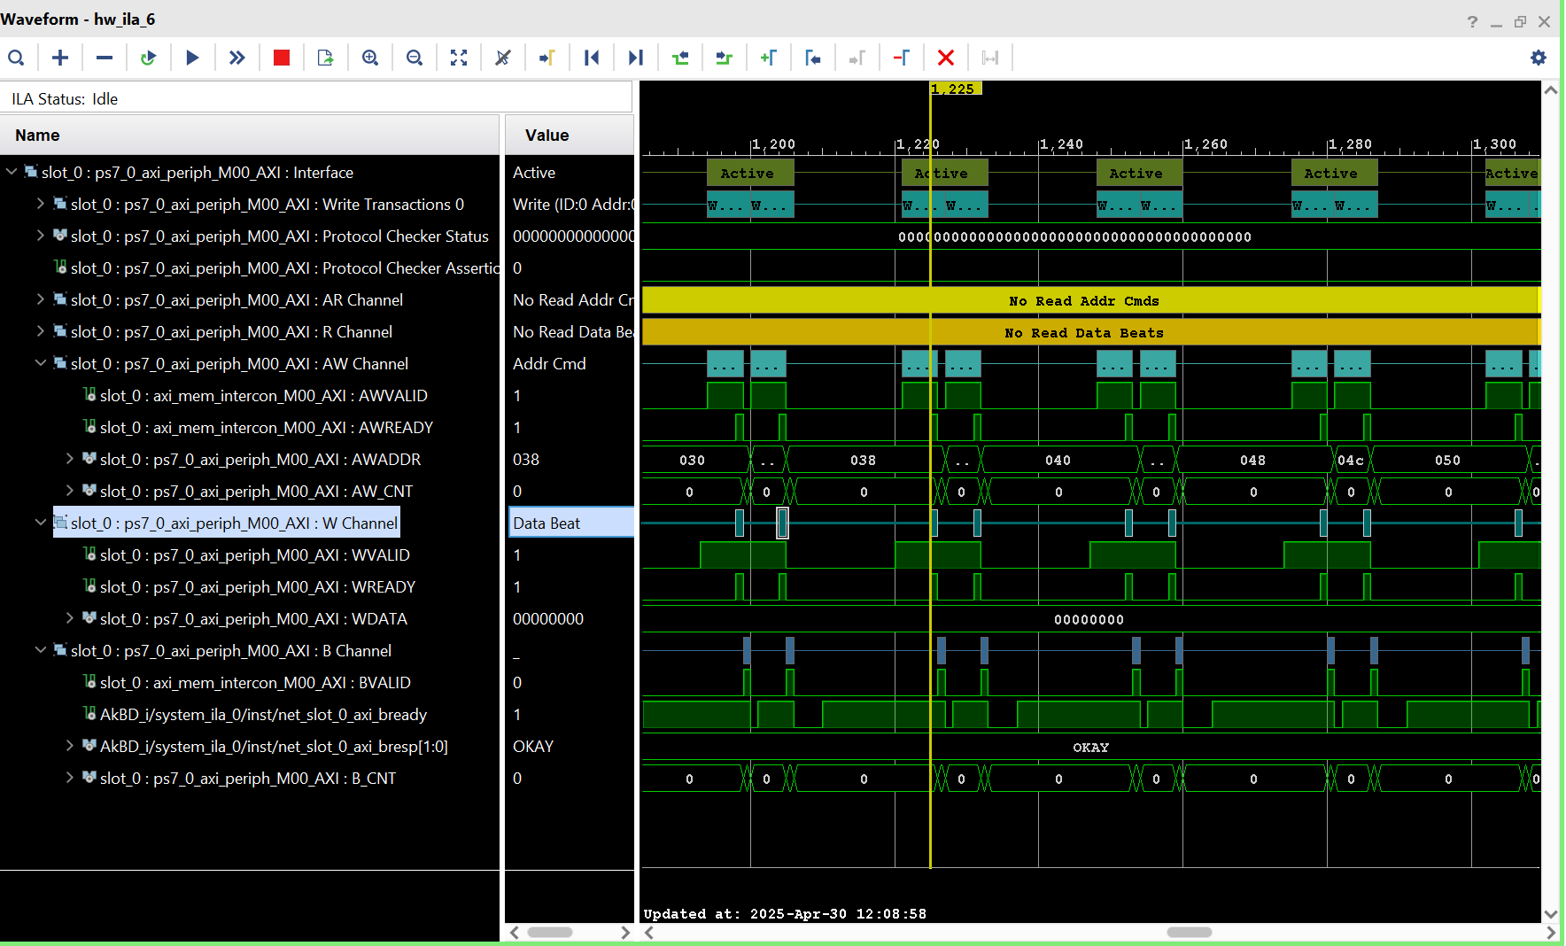
Figure 10. Working DMA output.

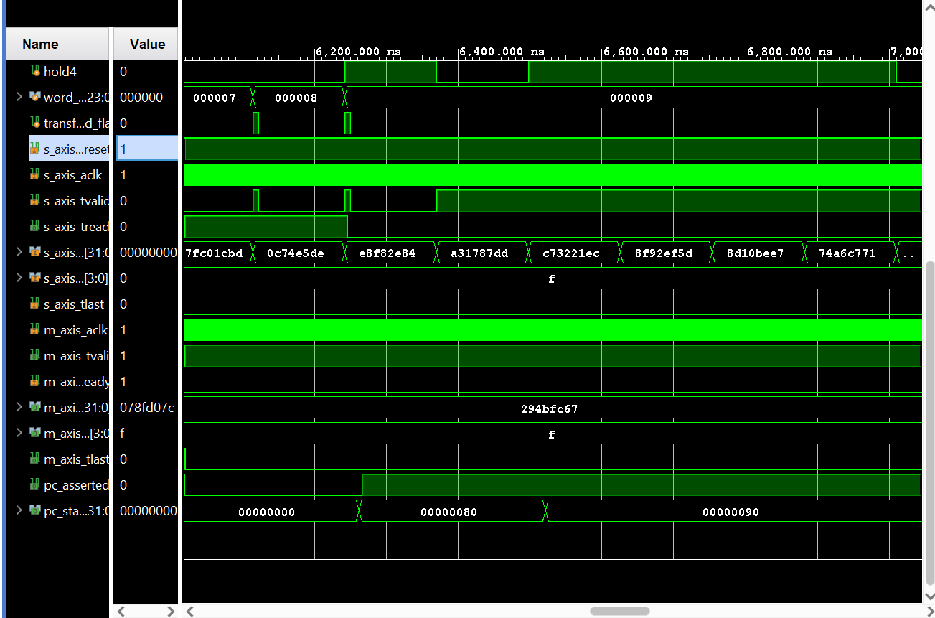
Figure 11. FIFO saturated output.
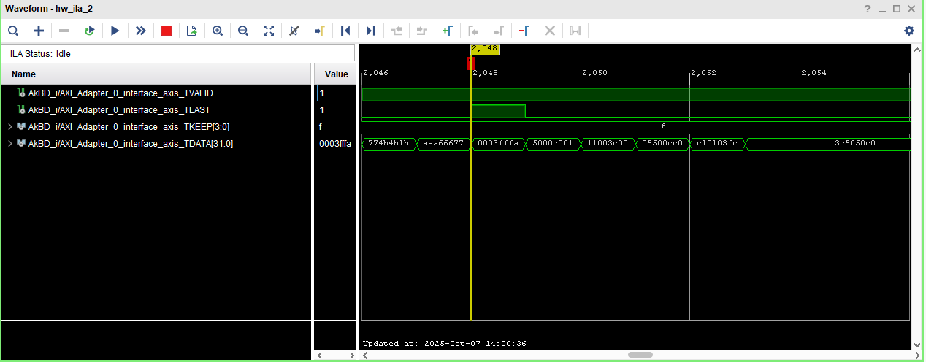
Figure 12. Tlast Leaking output

In regards to figure 12, this tlast leaking issue has been fixed, but if one were to see tlast firing before the end of packet, one can expect to have data loss, and one should be able to confirm that issue by comparing ILA output to figure 12.

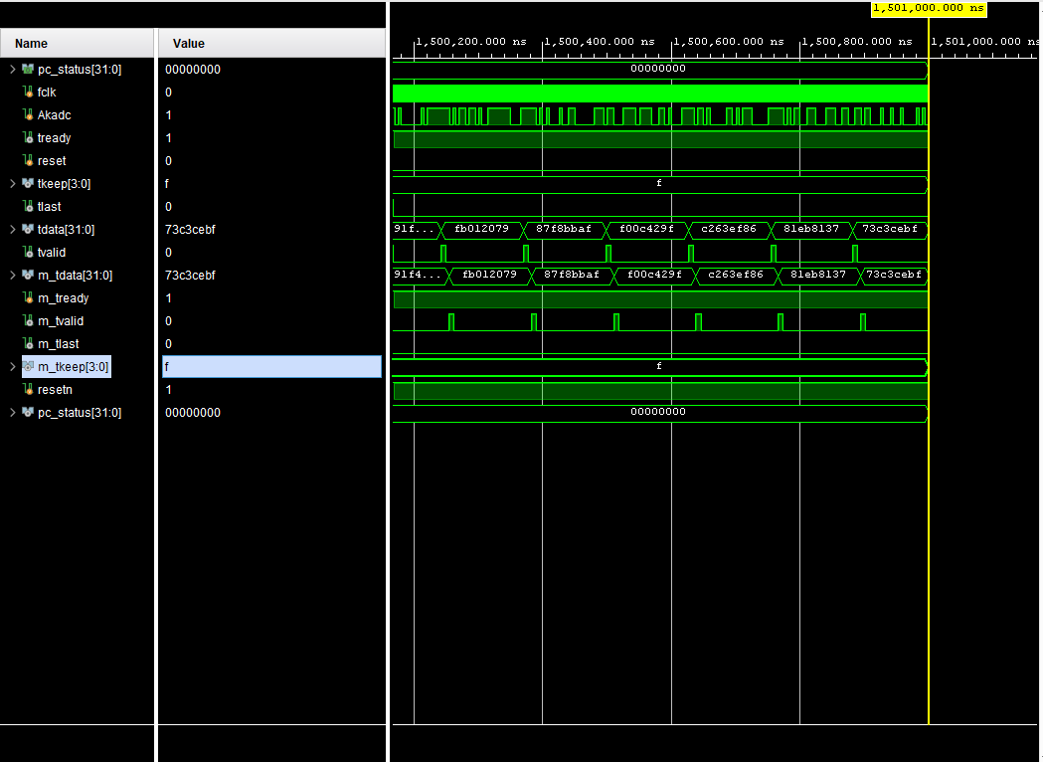
Figure 13. Axi_Adapter perfect simulation.

Figure 13 shows a perfect simulation, which one can use to at least match theoretical behavior of any Verilog modifications, but it has been proven that the simulation and reality do not match the complex behavior of the system. None the less, one can still use this output to debug any problems one might be facing.

PS Design Decisions / Methodology

Now that the data is in the DRAM thanks to the PL, this is where the PS takes up the slack and completes the other half of the transactions to get the data packaged and into Linux.

Figure 11: PS Block Diagram
Petalinux: This is the Xilinx software that one compiles to make a custom Linux image combining one’s hardware design, MMIO, and Linux together to work cohesively. Setting this tool up involves the use of WSL (Windows Subsystem for Linux) and Ubuntu to match the exact version of Vivado that one is using. For example, Vivado 2023.2 requires the use of Petalinux 2023.2 (no other version will work) as well as the list of supported operating systems for Petalinux. In the case of this work, Ubuntu 18.04 LTS was used. Using a custom Linux image allows one to bake in a custom driver which can directly interface with the PL hardware, namely the memory mapped registers and values of the AXI DMA. Using a basic premade image simply is not a feasible idea here, as it robs the operating system of all knowledge of what is going on in the PL. This information is communicated through what is called a device tree and is a core UNIX concept. A device tree is a file containing all the hardware information that will be used by Linux, and details the exact driver, memory addresses and properties of the hardware. This is especially important in driver development and low-level coding, which will be explained in following sections. In this design, the device tree did not have to be specifically modified. For more details on Petalinux, please visit Link 3 and 4.

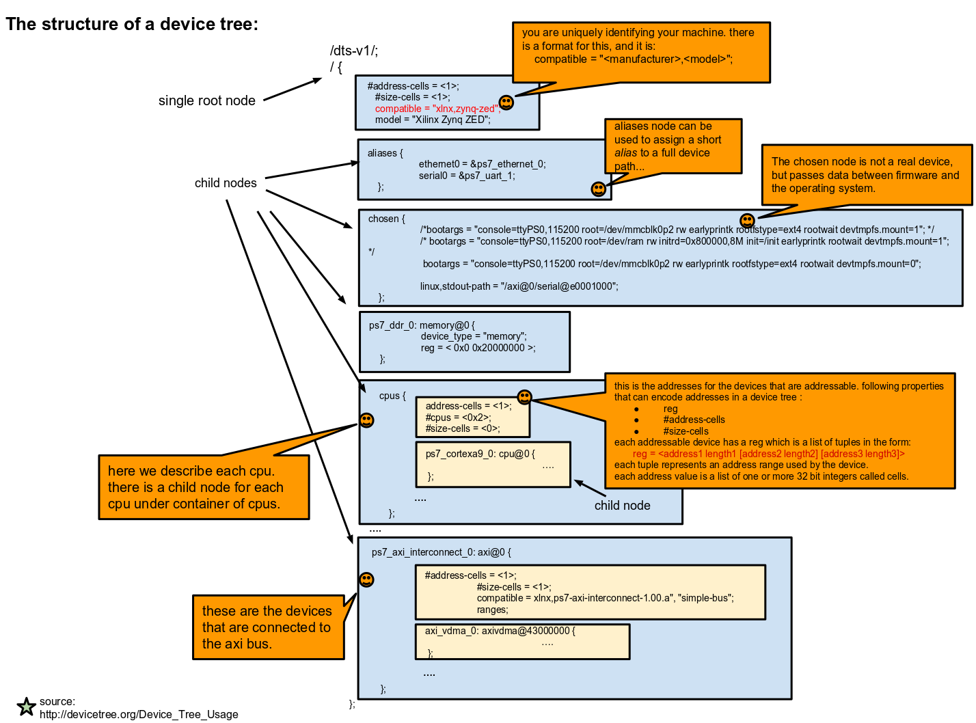
Figure 12: Device Tree Structure
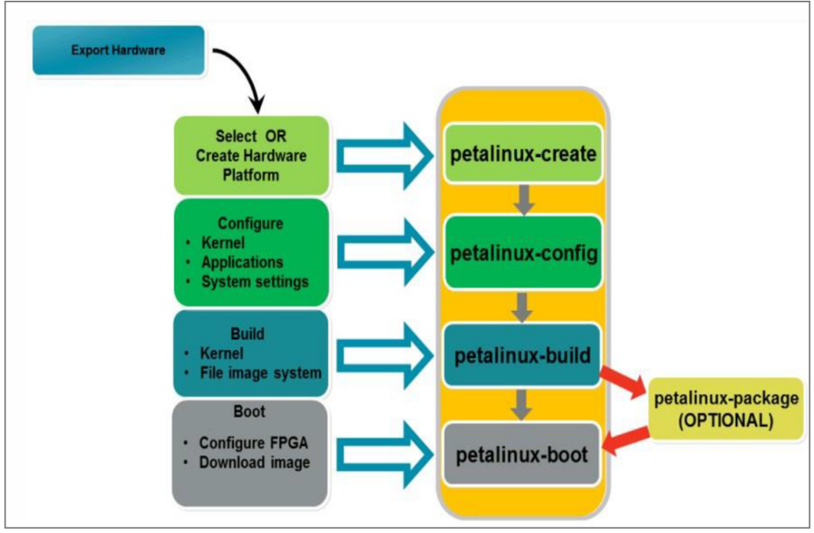
Figure 13: Petalinux Workflow

Petalinux Steps:

source /opt/Xilinx/petalinux/2023.2/settings.sh 1)
petalinux-create --type project --template zynq --name <proj folder name> 2)
petalinux-config --get-hw-description <path to XSA> 3)
petalinux-create -t apps --name <app name> 4)
// make apps, then in the apps folder put the c code.
petalinux-config # PetaLinux settings
petalinux-config -c kernel # kernel options
petalinux-config -c rootfs # packages USE THIS ONE ONLY 5)
petalinux-config -c uboot # U-Boot options
petalinux-config -c busybox # BusyBox options
petalinux-build 6) CLOSE ALL APPS, VERY RAM HUNGRY
petalinux-package --boot --fsbl ./images/linux/zynq_fsbl.elf --fpga ./images/linux/AkBD_wrapper.bit --u-boot --force 7)
petalinux-package --wic 8)

DMA-Proxy Driver Single Channel Version: To truly explain the inner workings of the dma-proxy driver, one must first understand how to control the dma from Linux, and CMA. One accesses the DMA through using the mmap() function in C to open the memory page tables and expose raw memory addresses. Through this process, one exposes the control registers for the DMA. The programming order and individual register offsets and their bitmapped functions will not be explored here but are available both in the code as well as at Link 5. One can then by setting these registers in the correct order, control the DMA to start stop, write into a certain address and so forth. The DMA must write to the correct CMA backed address. This function is implemented in the driver as well as in Petalinux by calling the driver with buffer_count and the frame_bytes variables when one initializes the driver. By default, on bootup, the driver defaults to frame_bytes=33554432 (32 MB) and buffer_count=1. Buffer count relates to how many packets one wants to capture, as denoted by tlast. Frame_bytes denotes the size of an individual packet. CMA stands for contiguous memory allocation. Only buffer_count=1 results in continuous PRBS, as anything more causes the DMA to reset, and the PRBS to break. CMA size is set in Petalinux-config and is critical that only CMA is used for this data. CMA stands for contiguous memory allocation, and like an array, is full of memory addresses that are contiguous, which allows for continuous data to be written without any breaks, and also allows the rx code to open this memory region, directly read the data contents without breaking any patterns, ensuring that the data ordering remains exactly the same. Now moving onto driver structure, an important notice is made, DO NOT RESET THE DMA in the userspace code or in the driver code, as that only forces the dma into a confused state, and does not work properly, also, don’t reset the FIFO at all. Either of these actions cause the system to break and isn’t needed. (C code handles throwing stale data out) The addresses of the dmas need to be given in the device tree so that the driver can latch onto them and control them accordingly. The driver can control the dma through setting various values in the dma’s control register and constantly incrementing addresses for the dma to write to, which facilitates transfers. There is a debug mode in the driver which will spit out each transaction’s flags and addresses, but it is not recommended to enable this unless in depth debugging is required, as the amount of data printed not only exponentially slows down larger transactions, but can also cause data to be broken as the OS fires various process interrupts. If one has to use this debugging feature, it is recommended to maybe transfer 25 words, no more since this will print statistics for 25 words. As a general rule, the more repeated print statements one has, the more likelihood for error, as well as slowdown is accrued.

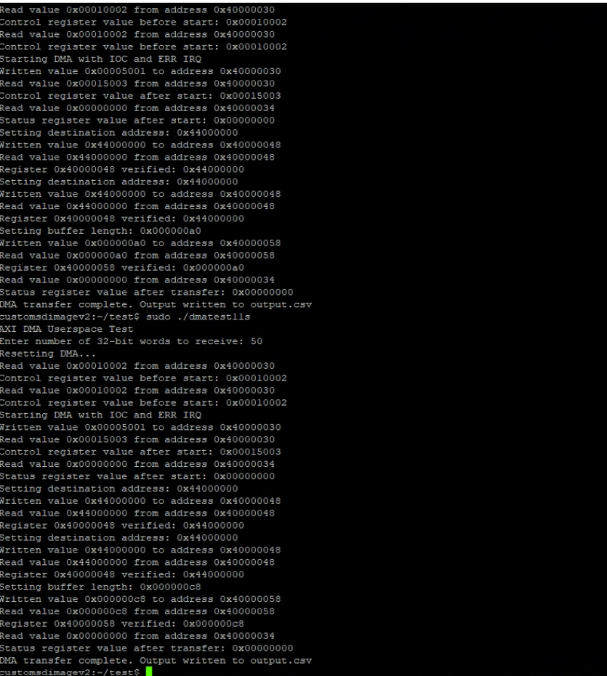
Figure 14. Debugging mode driver output.

Multiple Channel Driver :
The 3 channel driver is quite similar in structure to the single channel, and such, only the applicable differences will be mentioned here. Firstly, in the 3 channel driver, each dma is registered as its own device, with its own address and control registers. Secondly, there is now a data gate control register which effectively gates both the data and the clk into the 3 dmas so that all 3 dmas are synced in time when transactions are requested. This is required as without the data gate, all 3 of the dma transactions happen at slightly different offsets in time, causing all of the data to be misaligned, which can cause troubles when it comes to using the data to analyze IC behavior. To mitigate this issue, the gate physically synchronizes all 3 channels so that they begin receiving data and clk simultaneously.
An important point to make here is DO NOT RESET THE DMA, or set any code to do so, as that will send the DMA into a confused state, and break the system. Not resetting the dma is perfectly fine, and just results in the first 1.2megabit of data being thrown out, which isn’t a problem at all.
One big thing regarding CMA interplay between Vivado, the driver, and the rx code is that for the multiple channel design, Vivado expects 64MB and so does CMA for 3 regions, so if the driver only allocates 32MB i.e. a single frame or buffer, then the issue becomes that none of the memory addresses align and the entire system fails, as the driver does not see the correct dmas at the correct addresses. In order to avoid this issue, ensure that the multiple channel driver requests 2 frames of 32MB, totaling 64MB so that the addresses are correct, as shown below. Now, in the rx code, which will be covered later, a single frame is requested to maintain continuous data, DO NOT Request more than 1 frame, unless it has been validated to be continuous, otherwise, there will be a break in the data.

static u32 param_buffer_count = 2;
module_param_named(buffer_count, param_buffer_count, uint, 0444);
MODULE_PARM_DESC(buffer_count, "Frames in buffer");

static u32 param_frame_bytes = 33554432;
module_param_named(frame_bytes, param_frame_bytes, uint, 0444);
MODULE_PARM_DESC(frame_bytes, "Bytes per frame (BTT)");

RX Code (Userspace):

Rx_test3:
rx_test3 and rx_test2 are extremely similar, and will be explained together, since the only difference is that rx_test3 uses pthread to manage 3 concurrent dma tasks. Firstly, one must open the devices located at /dev/dma_proxy#, where # denotes the number of the dma, and then one must mmap their memory addresses according to the MMIO address table shared above. Furthermore, one must synchronize the cpu with the l3 caches or perform coherent transfers which ensure that the cpu sees the most recent data in dram as the dma shuffles data into the dram. For rx_test3, ensure that the no-dedup option is 0, since this option removes duplicated pairs, and isn’t needed anymore. There are also debug functions in both versions of the code, intended to be used only when the dma is in an error state, and NOT to be used otherwise. These functions greatly slow down overall operation and can easily cause the incoming data to be broken. For code usage, please refer to the menu which shows up as the code is run. The last important note here is that for speed reasons, the data is directly written into 3 separate .bin files which allows the transactions to complete very quickly and ensures that no data is lost. Once all 3 transactions have run, then the code opens the separate .bin files, and writes one total csv file for ease of interpretation. It is highly recommended that after every 5 csv files recorded, that the oldest one is deleted for SD card space.

As far as tunable knobs go, the below values are the tried and true values. It is HIGHLY recommended to stick with these values, unless one has an innate knowledge of what they are doing.

static size_t g_buffer_count = 1;
static size_t g_frame_bytes = 33554432;
static size_t g_batch_frames = 1;
static int g_verbose = 1;

static const char *COUNTER_FILE = "capture_counter.txt";
static int g_write_bin = 1;
static int g_write_csv = 1;
static int g_reset_dma_before_capture = 0; // Reset DMAs before starting
static int g_no_confirm = 0; // Skip confirmation prompt

// Transform knobs
static int g_msb_first = 0;
static int g_swap_bytes = 0;
static int g_rev_bits_in_byte = 0;

// Post-process controls
static int g_dedup_pairs = 0;
static int g_skip_first_word = 1;
static int g_drop_zeros = 1;
static size_t g_skip_bits = 1200000;
static size_t g_capture_multiplier = 1;
static size_t g_preview_words = 32;

// FPGA pipeline compensation offsets (in words)
// Adjust these based on your hardware
static size_t g_offset_dma1 = 0; // Set to measured offset for DMA1
static size_t g_offset_dma2 = 0; // Set to measured offset for DMA2

Testing Procedure

Testing procedure is quite straightforward with only one or two notable guidelines to follow.
Best practices (useable data is not guaranteed if one doesn’t follow these guidelines)
- Boot up the board with the external clock running (This ensures that the Verilog front end gets flashed properly).
- Do not turn off the external clock until after the csv file has been written. (This gives time for dma transactions to fully finish).

  - Debug command : sudo rm cap_*.bin output_*.csv capture_counter.txt
Standard procedure
- Turn on the external clock
- Boot up the board
- Connect either only ethernet or ethernet and uart (More reliable).
  - For ssh ensure that you have a static ip address
  - ssh petalinux@192.168.1.10 pw: root
  - Uart: Baud rate = 115200
- cd test
- if the code isn’t compiled, then gcc -O2 -Wall -Wextra -std=gnu11 -pthread -o rx_test3 rx_test3.c
- if the code is compiled, sudo ./rx_test3 #words -–lsb-first
- scp output.csv John@192.168.1.123:"C:\Users\John\Downloads\"
  - this is just a variation of scp, so modify it according to ones needs
- run analysis on the csv.
Note: the oldest bit is the first one, so as you read the column the bits are oldest to newest.

Addendum
For any extra details that are not found in this document, please refer to ResearchNotes.txt which can be found in the box backup, which contains all of the information that I used while developing this system, and can help walk one through the development, though this shouldn’t be necessary.

Next Steps

Future work will focus on increasing the maximum input frequency beyond the current 250 MHz to further enhance acquisition speed and performance.

Links
[1] https://files.digilent.com/resources/programmable-logic/zedboard/ZedBoard_HW_UG_v2_2.pdf

[2] https://vhdlwhiz.com/how-the-axi-style-ready-valid-handshake-works/

[3] https://www.amd.com/en/products/software/adaptive-socs-and-fpgas/embedded-software/petalinux-sdk.html
[4] https://digilent.com/blog/my-embedded-linux-adventure-intro-to-petalinux/
[5] https://docs.amd.com/r/en-US/pg021_axi_dma/SG_CTL-Scatter/Gather-User-and-Cache-Control-Register-Offset-2Ch
[6] https://docs.amd.com/r/en-US/ug953-vivado-7series-libraries/BUFMRCE
[7] https://docs.amd.com/api/khub/documents/B18GeWPD8fFG6f4ogHK96g/content

